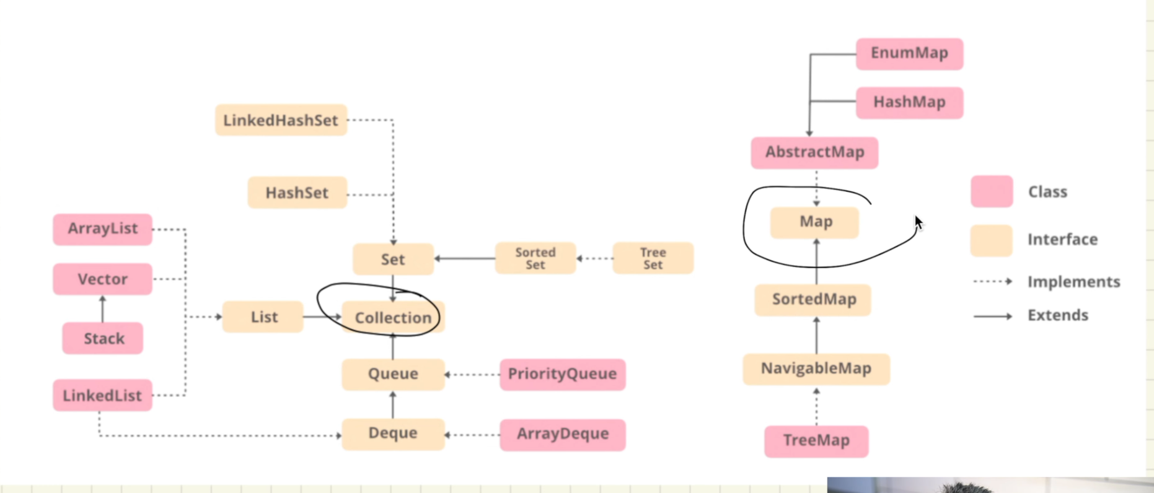

Java has provided all there amazing classes and interfaces already in java.util package to work with

Among them two main ones are collection and map, these both are interfaces

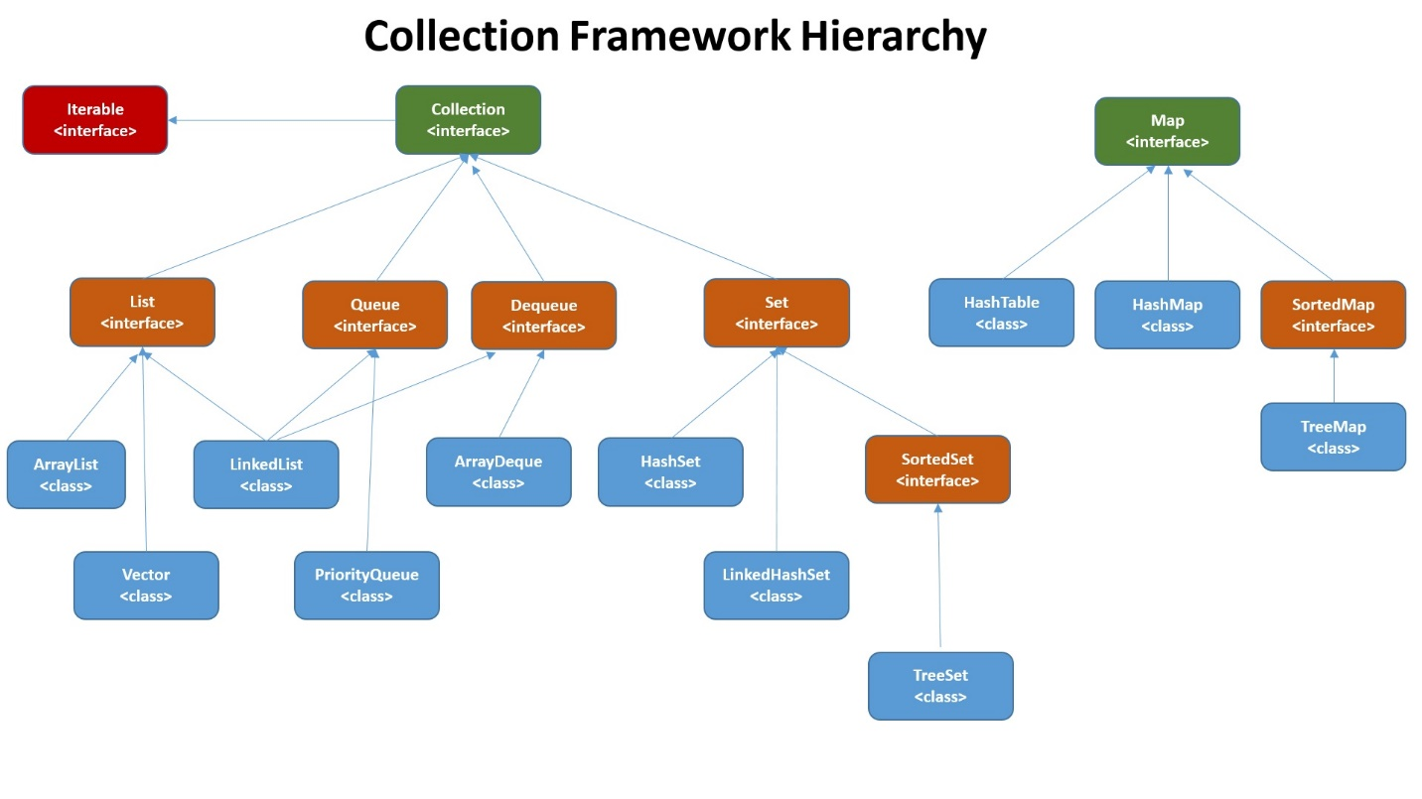

As per the above diagram we see,

Collection extends Iterable

List extends Collection

Arraylist implements List

So these below code makes sense

